**Admin delete a comment or answer**

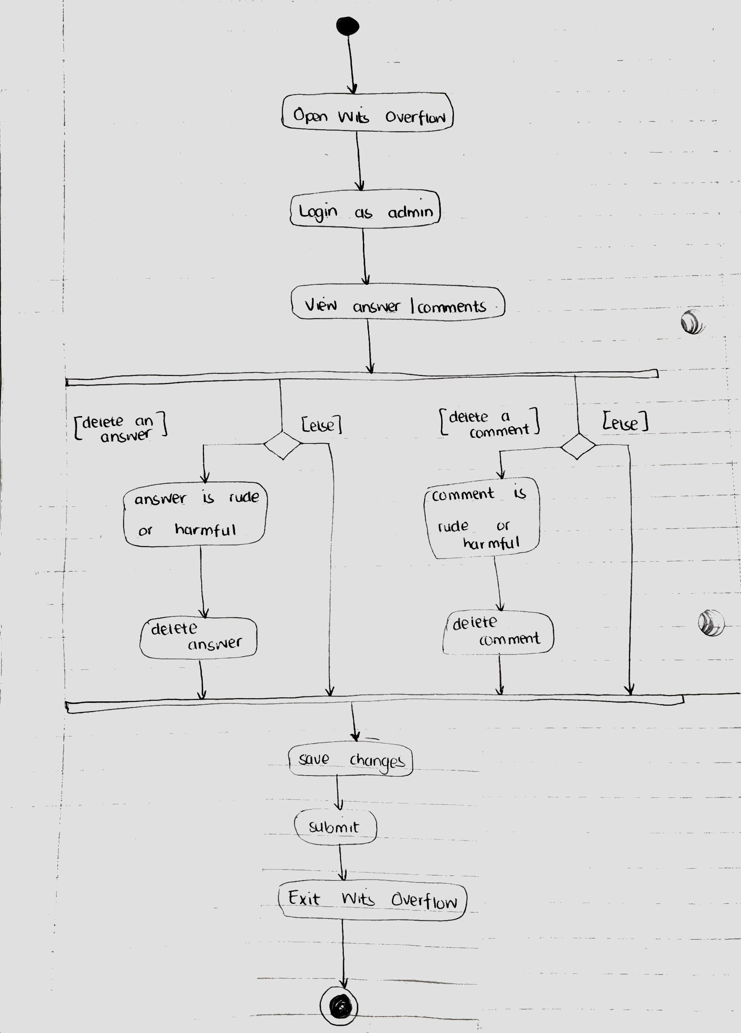

**Close a question and mark question as correct or not**

